# 

# Secure Software Architecture Code Development Team Project -Testing Results

Table of Contents

Secure Software Architecture Code Development Team Project -Testing Results 1

Authn – 01: Test authentication functionality using certificates 3

Oper-01: Validation of package installation 4

Sec-01: Data in transit is encrypted between smart device/sensors and hub 5

# 

# Authn – 01: Test authentication functionality using certificates

The application requires a valid certificate to authenticate to the smart devices. Without a valid certificate connection would not be established.

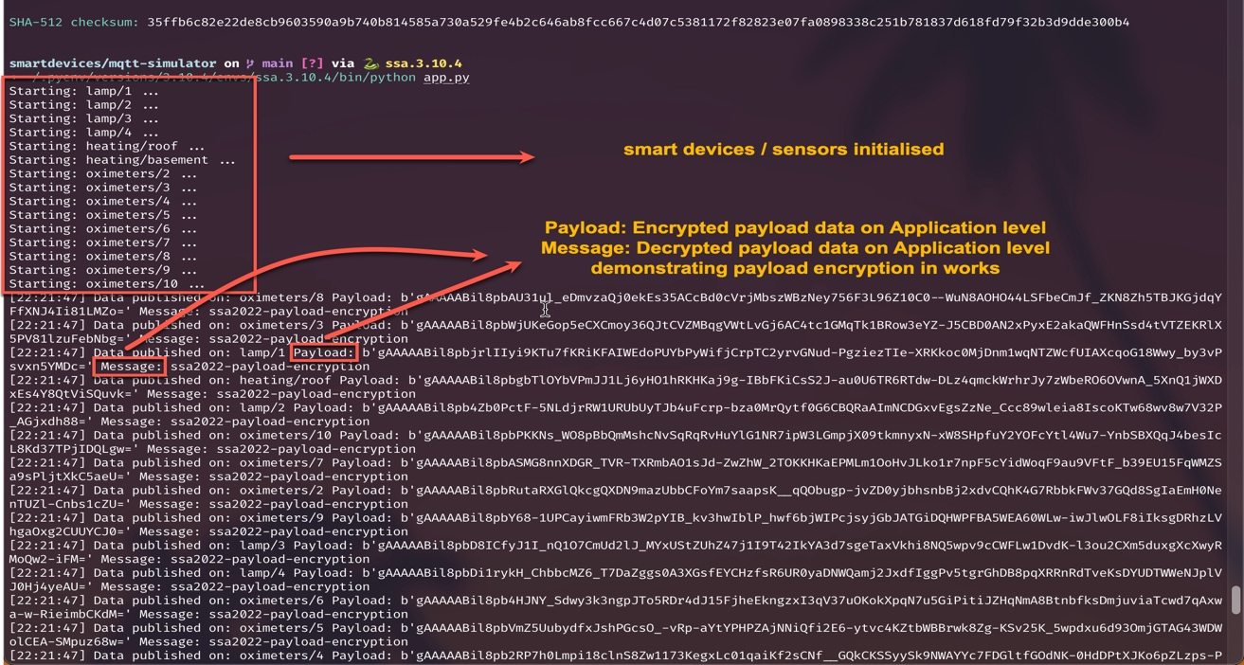

# Oper-01: Validation of package installation

The system is able to validate the package prior to installation by crosschecking MD5 or SHA256 hash digest from local downloaded packet to online official repository.

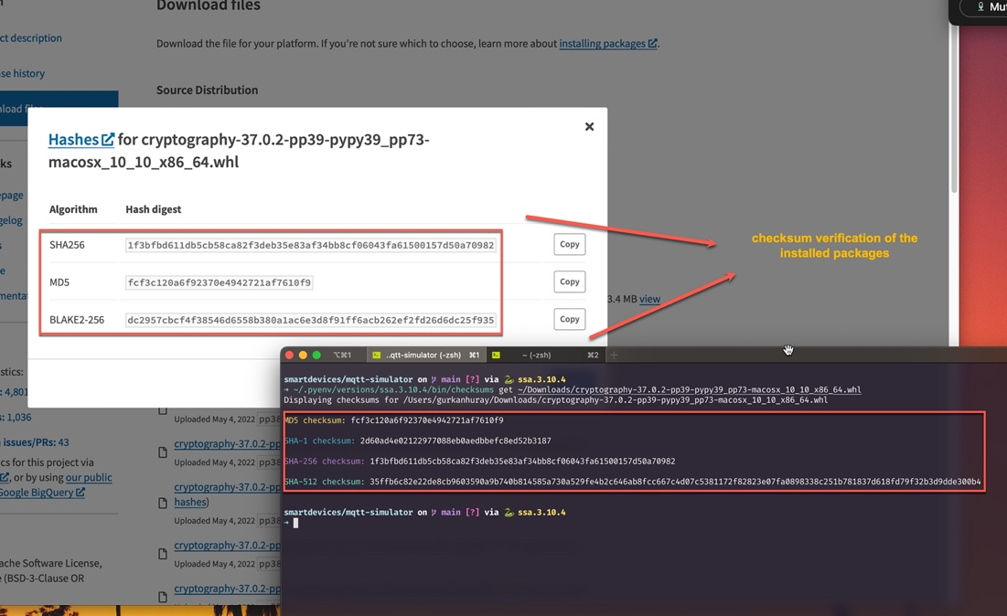

# Sec-01: Data in transit is encrypted between smart device/sensors and hub

Validating encryption in transit of payload data on the application level.

